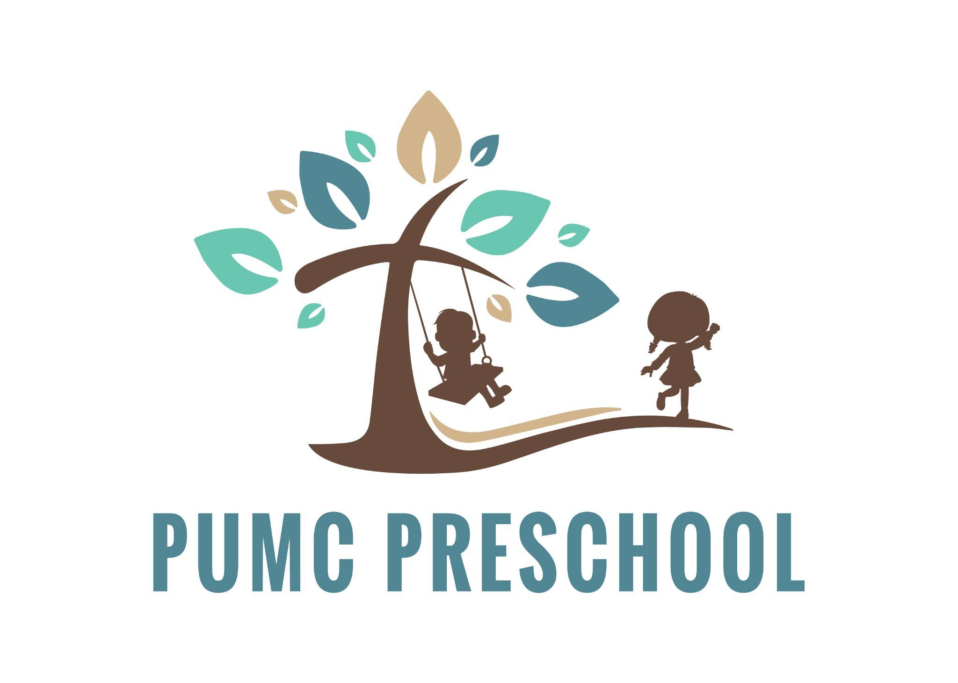**2025-2026 PRESCHOOL REGISTRATION**

**Please select the program you would like to enroll your child in.**

| 1. | **Pre-K Program**: This is a 4-5’s program that meets Monday - Friday from 9:00AM - 1:00PM. *Program Cost - $375/month.* Students must be 4 years old by August 1, 2025. Children **MUST** be toilet trained and able to use the bathroom independently in order to enroll. |
| --- | --- |
| 2. | **Beginner’s Program**: This is a 3-4’s program that meets Monday, Wednesday, and Friday from 9:00AM - 11:30AM. *Program Cost - $210/month*. Students must be 3 years old by August 1, 2025. Children **MUST** be toilet trained and able to use the bathroom independently in order to enroll. |
| 3. | **Little Tot’sProgram**: This program meets Tuesday and Thursday from 9:00AM - 11:30AM. *Program Cost - $140/month*. Students must be 2 years old by March 1, 2025. Children **MUST** be toilet training and working on using the bathroom independently. |

**STUDENT INFORMATION**

| Student’s Full Name: |
| --- |

| DOB: | Age: | Gender: |
| --- | --- | --- |

| Home Address: | City: |
| --- | --- |

| Name to be used in class: |
| --- |

**PARENT INFORMATION**

| Mother’s Name: | Phone number: |
| --- | --- |

| Email Address: | Employer: |
| --- | --- |

| Father’s Name: | Phone Number: |
| --- | --- |

| Email Address: | Employer: |
| --- | --- |

Parent’s Marital Status: ___________________ Child living with:_________________________

**EMERGENCY CONTACT**

Please list at least ***TWO*** emergency contacts. These contacts should be individuals to be contacted if the child’s parents cannot be reached.

| Name: | Relationship: | Phone: |
| --- | --- | --- |
| Name: | Relationship: | Phone: |

**EMERGENCY TREATMENT AND HEALTH**

| Child’s Physician: | Phone: |
| --- | --- |

| Known Allergies: |  |
| --- | --- |

| Known Medical Conditions: |  |
| --- | --- |

| Known Vision Concerns: |  |
| --- | --- |

| Known Hearing Concerns: |  |
| --- | --- |

| Other Health or Learning Concerns: |  |
| --- | --- |

**In the event of a medical emergency, parents will be contacted as soon as possible. I give my permission for emergency transport. I understand that I am liable for all charges incurred.**

Signature: ___________________________________________ Date:____________________

**PERMISSION TO RELEASE**

The following individuals have permission to pick up my child at dismissal. I understand that these individuals must supply identification (driver’s license, etc.) as proof of identity before the child will be released.

| Name: | Relationship: | Phone: |
| --- | --- | --- |
| Name: | Relationship: | Phone: |
| Name: | Relationship: | Phone: |

**AGREEMENT TO PUMC PRESCHOOL**

PLEASE INITIAL AND SIGN BELOW

_____ I understand the PUMC Preschool Program is an educational and christian based program, students will be exposed to educational enrichment activities and will have chapel monthly with our PUMC Pastor.

_____ I understand that my child must be fully toilet trained and use the bathroom independently in order to enroll in Pre-K and Beginner’s and working on toilet training in order to enroll in the Little Tot’s PUMC Preschool Programs.

_____ I understand that tuition is due by the 1st of every month. I have reviewed the financial policy in the PUMC Handbook and agree to pay any late fees assessed to my child’s account for late payments made.

_____ I hereby grant permission for my child to use all playground equipment and participate in all school activities.

_____I hereby grant permission for the Preschool Director or authorized school personnel to take whatever steps necessary to obtain emergency care if warranted. These steps may include, but are not limited to, attempting to contact a parent or guardian, the child’s physician or any persons listed as an emergency contact provided by the parent. If the above mentioned can not be reached, school personnel will do any and all of the following: call for emergency services and transport to have the child transported to a hospital in the company of a staff member. Any expenses incurred while enlisting the help of medical personnel will be at the expense of the family.

_____I hereby grant permission for my child to be included in the documentation of our program/activities at PUMC Preschool through the use of photography, video, and printed materials as is deemed appropriate by school personnel. The forms of documentation may include, but are not limited to, promotional literature by PUMC Preschool, articles and/or photographs to be published in area newspapers, and photographs for our school webpage, media accounts (Facebook) and/or classroom blogs.

_____It is agreed that PUMC Preschool and staff assume no liability for injuries sustained as a result of participation in any and all PUMC Preschool programs.

_____ I understand that if PUMC Preschool’s staff feel that they can not meet the specific educational needs of my child, and/or keep my child safe and others safe, it may be recommended that my child find an alternative preschool setting to better meet his/her needs.

_____ I understand that if my child has a fever of 100 or higher, I will be called immediately to pick up my child.

_____I understand that my child should not attend or return to school until they are completely well, including no fever, diarrhea, or vomiting for AT LEAST 24 hours from the typical preschool related illness. I will not send my child to school with any illness symptoms.

Signature:______________________________________________ Date:_________________

**Items to be provided with Enrollment Packet are: $125 Registration Fee, Proof of immunizations, Birth Certificate, and Any applicable Custody Paperwork.**